Lights, Camera, Actions!

## Prerequisites

Before starting the demo:

Start the demo with by looking at the tasks database. Look at some tasks, some are for me and some are not for me.



Show the application that you can make from this demo. This shows **all** of the people’s tasks.

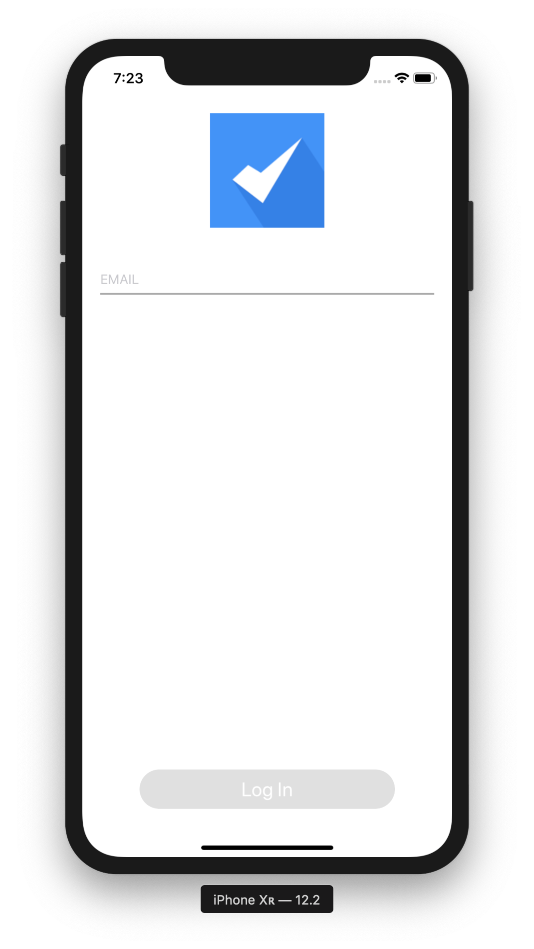

## SHOW ACTIONS

### Project

Open up the starter mobile project. Look at the actions, show that there are 2 types of actions all or single entity actions.

### iOS Application

Show how these applications work. Explain how these actions work.

### Methods

There are 2 new database methods **On Mobile App Authentication** and **On Mobile App Action**. These 2 methods receive and return objects.

**On Mobile App Authentication**

#### Description

The **On Mobile App Authentication database method** is in charge of managing mobile app authentication to 4D Server or 4D Developer. It is automatically called by 4D when a user agent sends a login request to 4D Server or 4D Developer for the first time.

**Note:** A user agent is defined by an application ID, a device ID, and a team ID. These ids are passed to the **On Mobile App Authentication database method** (see below).

The **On Mobile App Authentication database method** is always called for a first connection, even if the mobile application was built in Guest mode.

The method receives all necessary information from the mobile application in the $1 parameter (object), and must return an authentication status in the $0 parameter (object). You must declare and initialize these parameters as follows:

**On Mobile App Action**

The **On Mobile App Action database method** is in charge of managing actions requested by the mobile application for a specific session.

This database method is called by 4D when a mobile application sends an action request.

**Note:** For more information, please refer to the [4D for iOS documentation](https://developer.4d.com/4d-for-ios/docs/en/overview.html).

The database method receives required information from the mobile application in the $1 parameter (object), and must return the action status in the $0 parameter (object). You must declare and initialize these parameters as follows:

**NOTE:** These parameters are extendible, but you need to know what you’re doing and this is beyond the scope of our demo.

#### Segue

We all know that logins will be important for most people, and as a confirmed narcissist, I only want to see my tasks.

## ADD A LOGIN + RESTRICTED QUERY

Add `Email = :email`

This will create a filter query that will run a query on the table based on the email provided in the login and only show the tasks with that corresponding email.



Click the login button.



**BUILD APP**



Great, but like last time, the whole table gets updated. HMMM…



**Add the code, hmm we need to take a look at how this works from the tutorial.**

In order to not go into too much detail, you need to capture the email and be able to use it in the in the application to ensure that you are only updating MY (eternal narcissist) tasks.

**LOG OUT**

**On Mobile App Authentication**

$response.userInfo:=New object("email";$request.email)



**On Mobile App Action**



**openCloseAllTasks**



## Finalize

Set it to 100